EE314 Experiment 3 Report
Your Name - Your Student Number

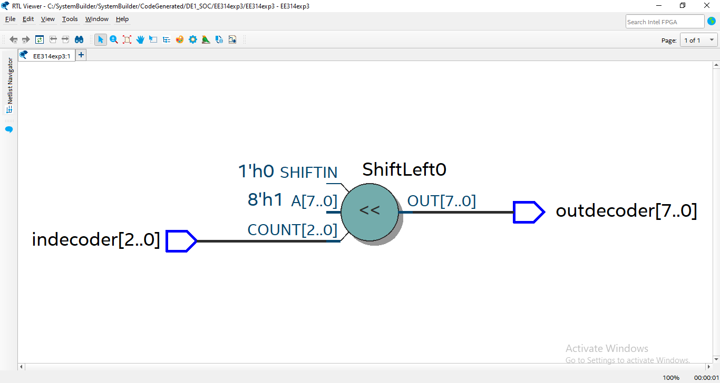
1.2.2
fig 1 rtl schematic of decoder
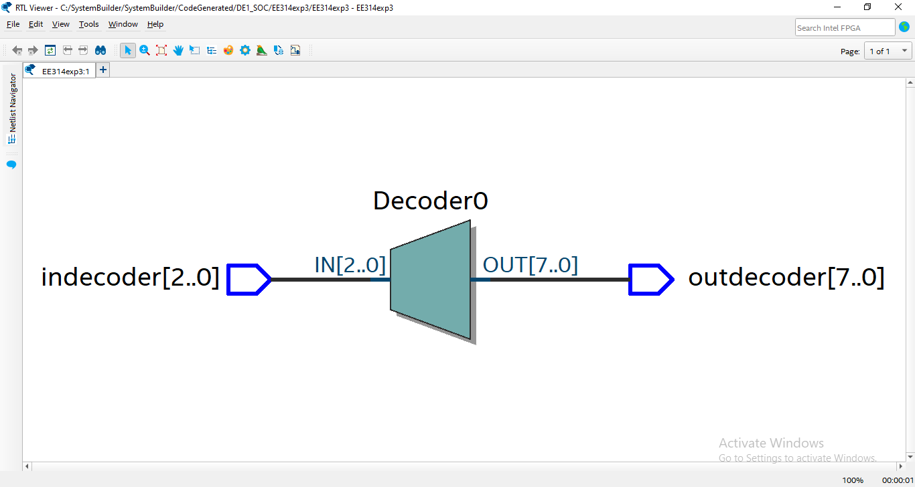
1.2.3
fig 2 rtl schematic of decoder

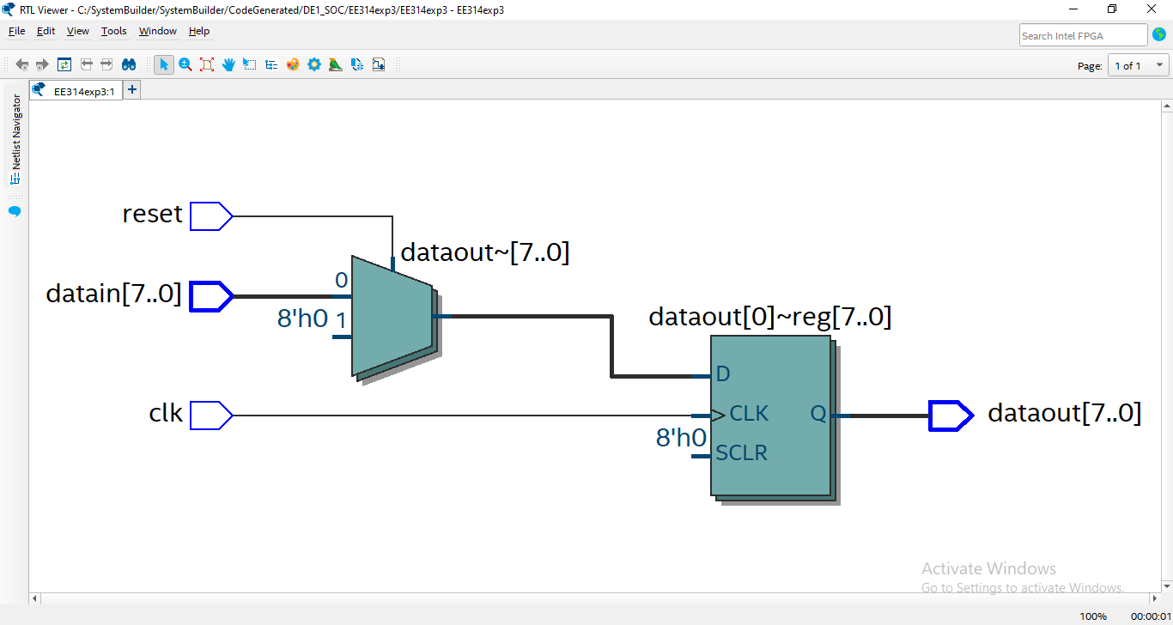
1.2.4
fig # figure name

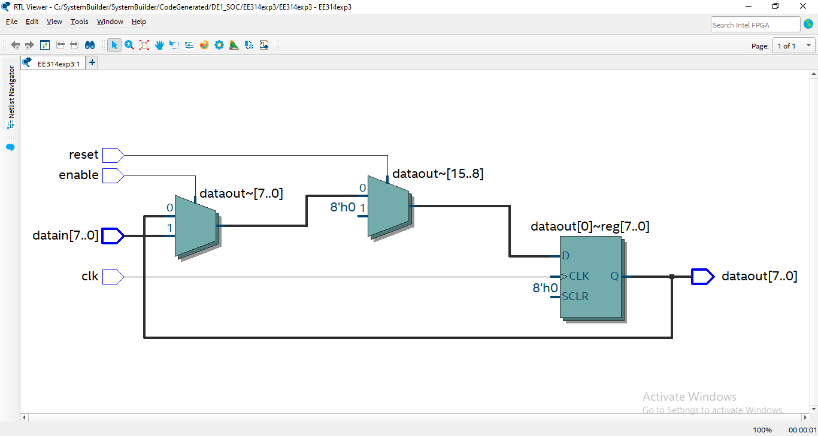
1.2.5
fig # figure name

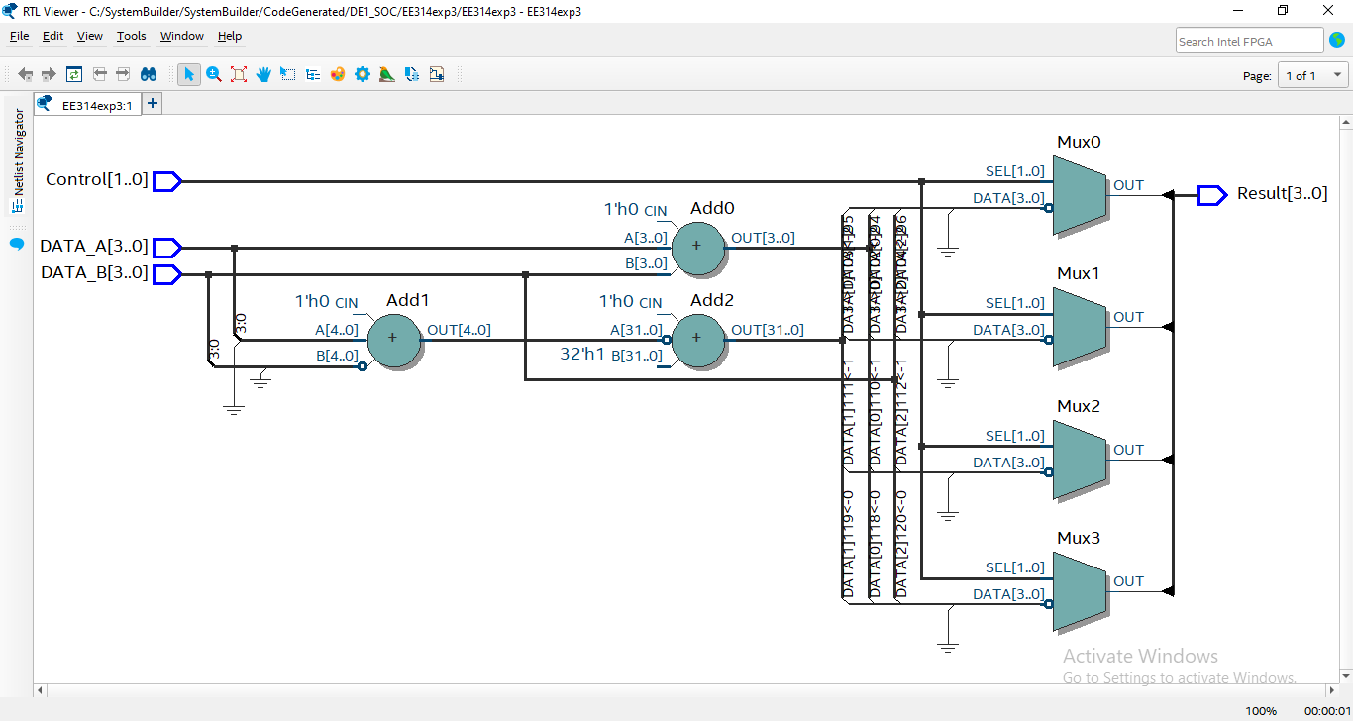
fig # figure name

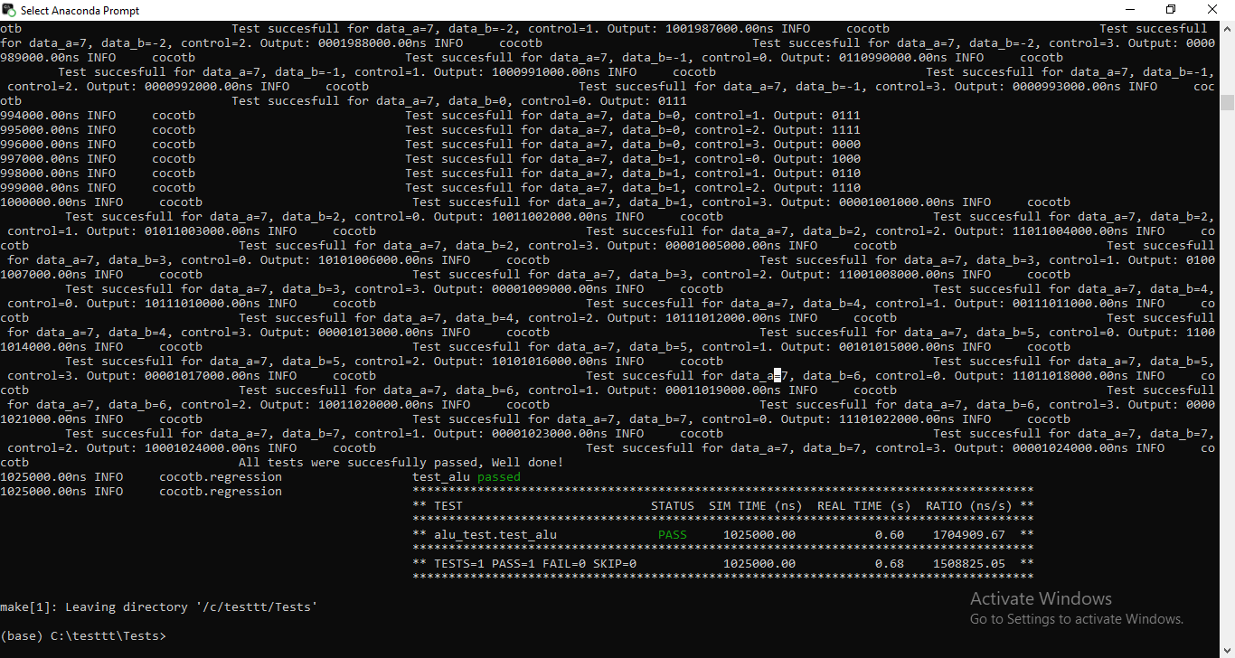
fig # figure name

1.3
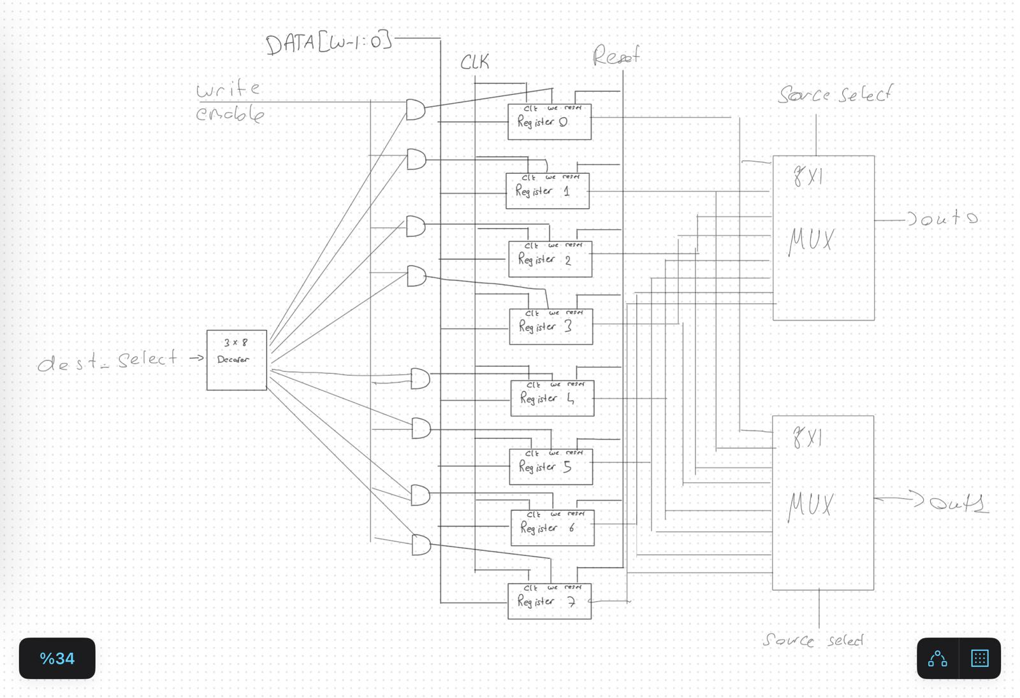
fig # figure name

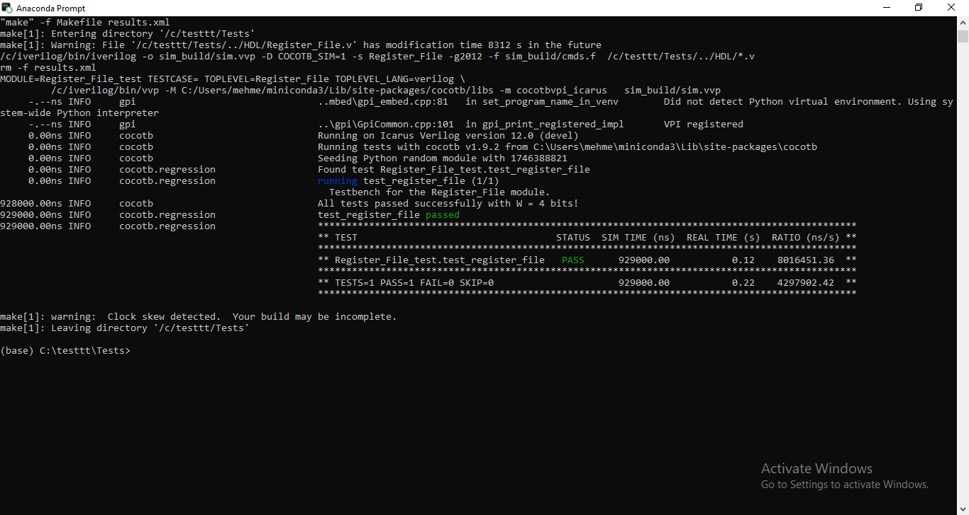
fig # figure name

Appendix

@cocotb.test()
async def test_alu(dut):

test_failed = False # Flag to track overall test failure
for Ain range(16):
A= A- 8
for B in range(16):
B = B - 8
for control in range(4):
dut.DATA_A.value = A
dut.DATA_B.value = B
dut.Control.value = control
await Timer(1, units='us')
if control == 0:
result = A+B
elif control == 1:
result = A - B
elif control == 2:
result = ~B
elif control == 3:
result = 0
result = result % 16
if dut.Result.value != result:
test_failed = True # Mark overall test as failed
cocotb.log.error(
f"Mismatch for data_a={A}, data_b={B}, control={control}: Expected {bin(result)[2:].zfill(4)}, "
f"Got {bin(dut.Result.value)[2:].zfill(4)}"
)
Log_Design(dut)
else:
cocotb.log.info(
f"Test succesfull for data_a={A}, data_b={B}, control={control}. Output: {dut.Result.value}")

# Final assertion for the overall result
if test_failed:
raise AssertionError("Some test cases failed. Check logs for details.")
else:
cocotb.log.info("All tests were succesfully passed, Well done!")

